**Task 10**

Install docker on EC2 and explore the docker commands (docker images, containers)

Installing docker

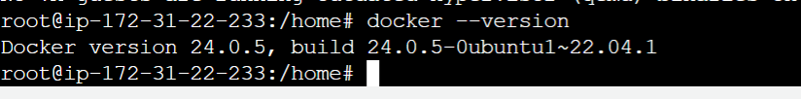

Docker Commands

